**Flask Blog Application Architecture**

**Before:**

Initially, this application used Monolith architecture. Both frontend and backend are implemented in a single codebase.

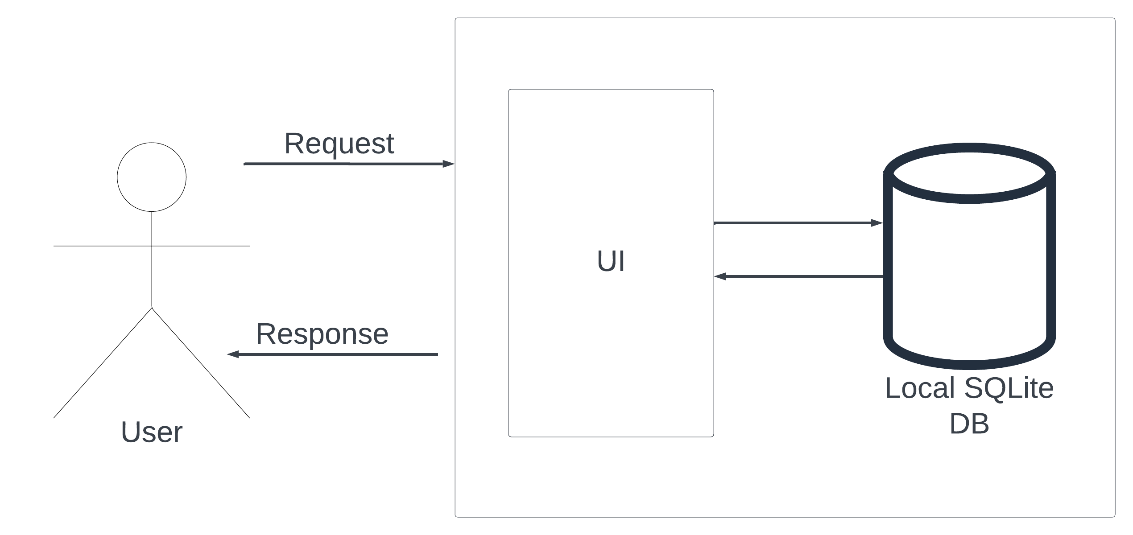

**After:**

This approach uses microservices architecture. I deployed CRUD operations on separate pods and exposed them as REST APIs. All four of these pods connect to a MySQL DB deployed on AWS.

